Below image/lines are output by the following command

$ cat /var/log/syslog

uid 1000 is user:frank

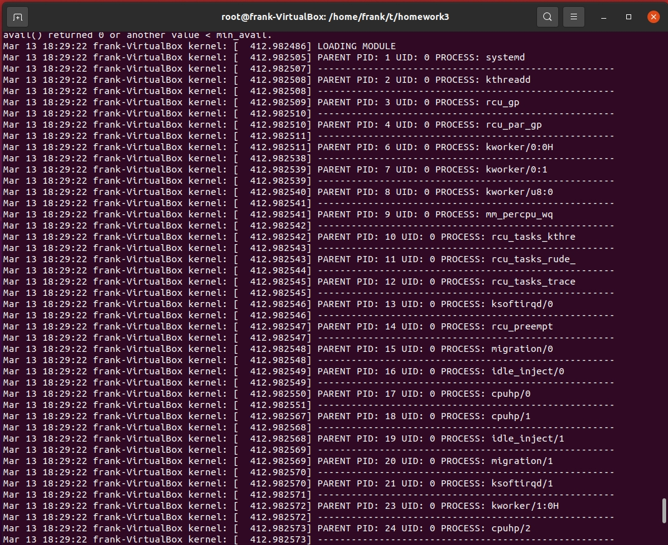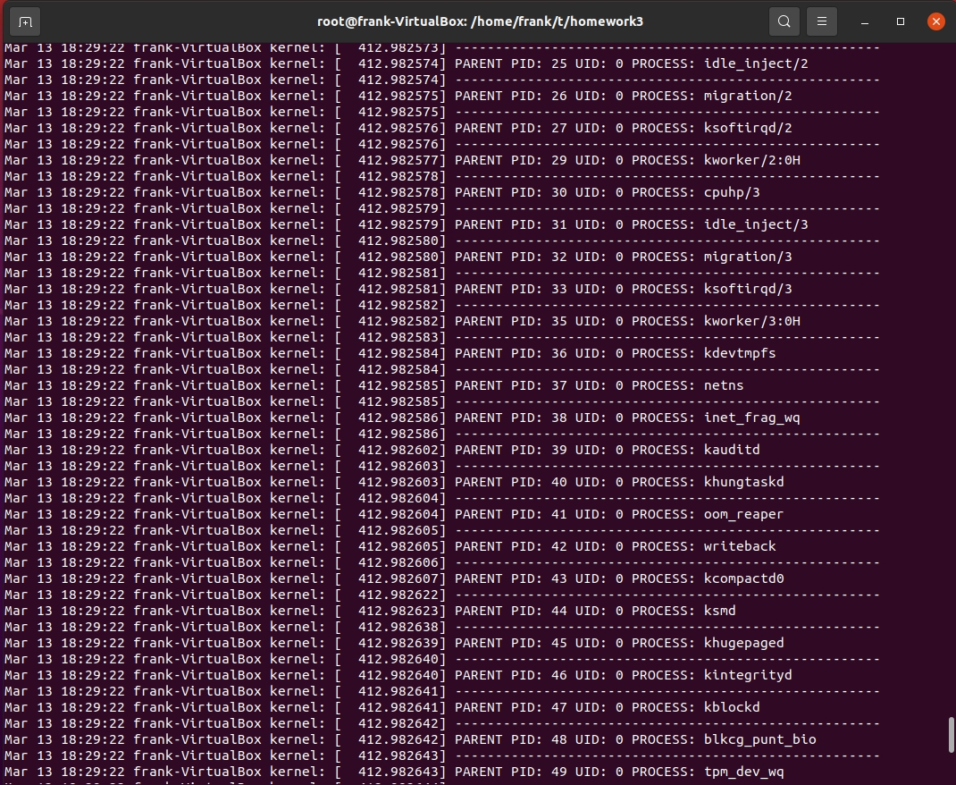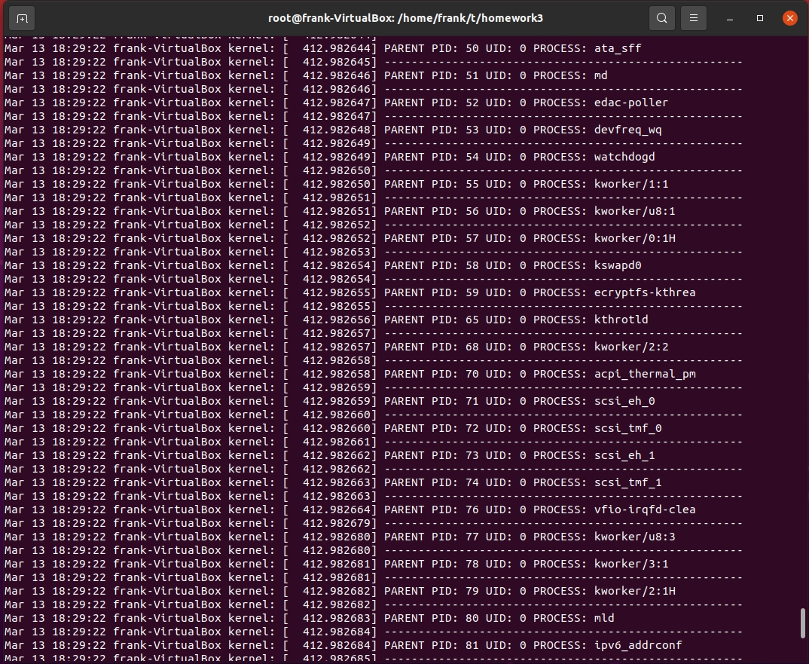

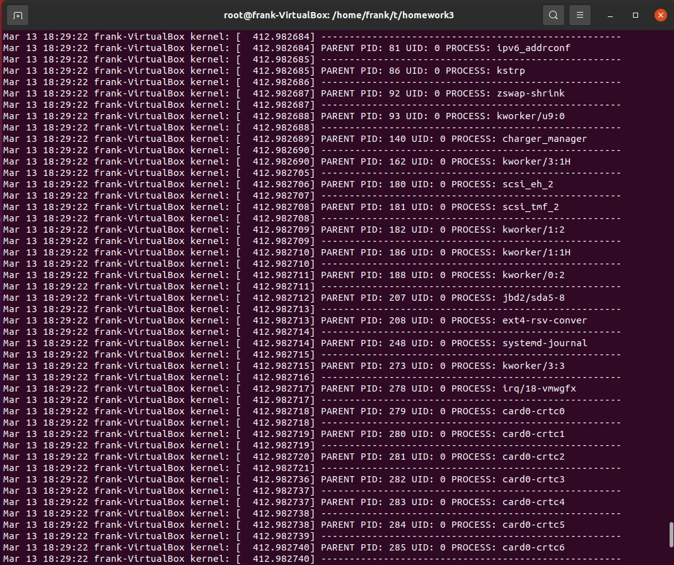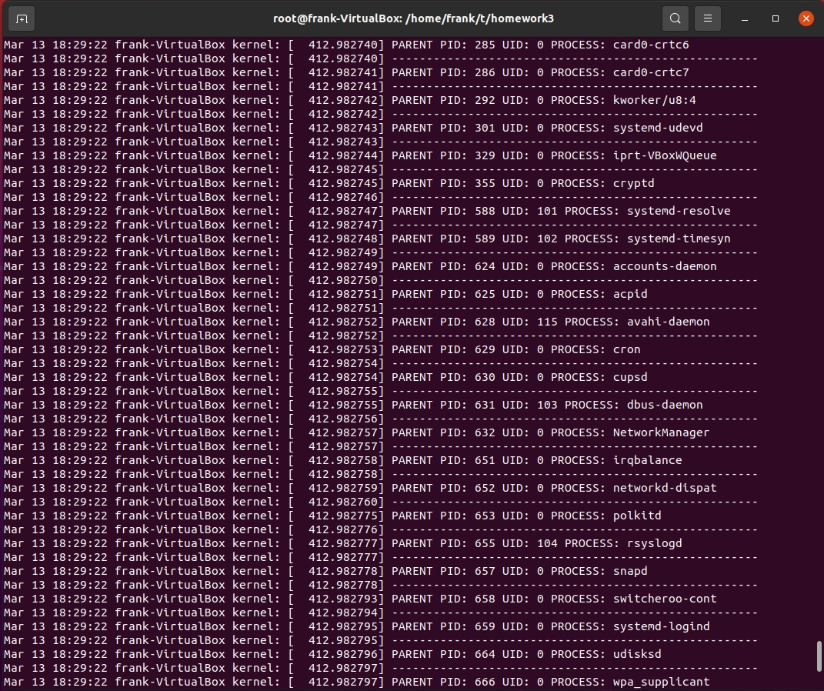

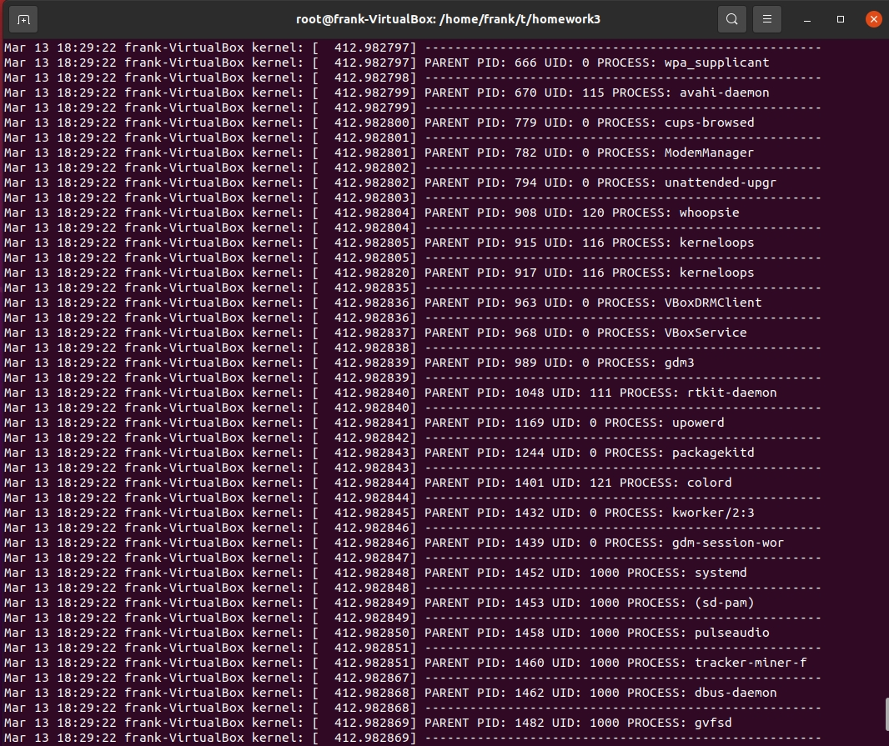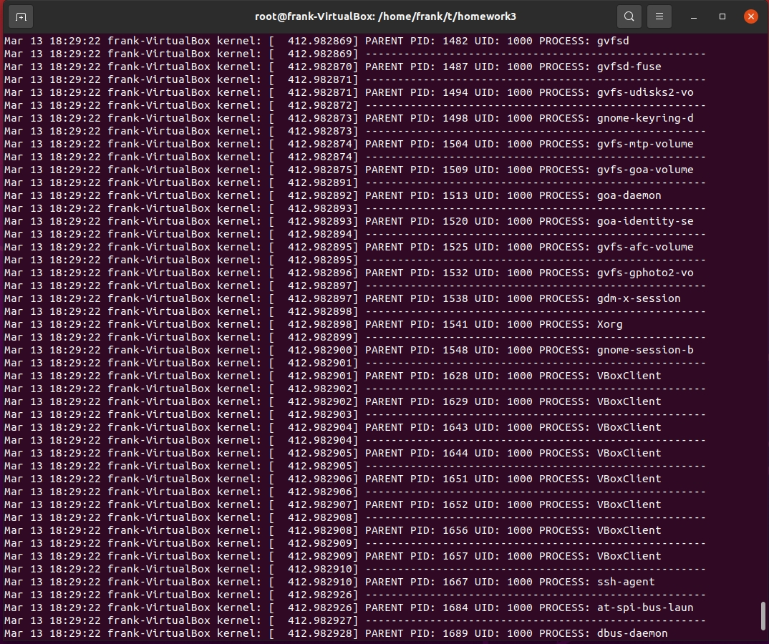

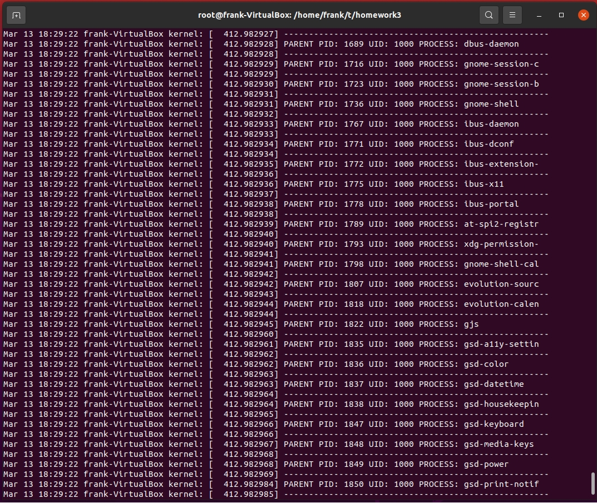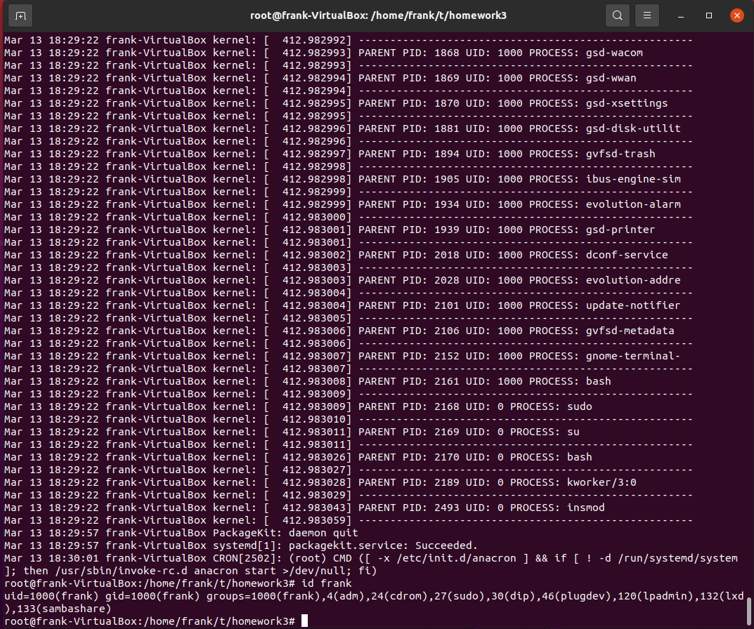

Mar 13 18:29:22 frank-VirtualBox kernel: [ 412.982486] LOADING MODULE

Mar 13 18:29:22 frank-VirtualBox kernel: [ 412.982505] PARENT PID: 1 UID: 0 PROCESS: systemd

Mar 13 18:29:22 frank-VirtualBox kernel: [ 412.982507] -----------------------------------------------------

Mar 13 18:29:22 frank-VirtualBox kernel: [ 412.982508] PARENT PID: 2 UID: 0 PROCESS: kthreadd

Mar 13 18:29:22 frank-VirtualBox kernel: [ 412.982508] -----------------------------------------------------

Mar 13 18:29:22 frank-VirtualBox kernel: [ 412.982509] PARENT PID: 3 UID: 0 PROCESS: rcu_gp

Mar 13 18:29:22 frank-VirtualBox kernel: [ 412.982510] -----------------------------------------------------

Mar 13 18:29:22 frank-VirtualBox kernel: [ 412.982510] PARENT PID: 4 UID: 0 PROCESS: rcu_par_gp

Mar 13 18:29:22 frank-VirtualBox kernel: [ 412.982511] -----------------------------------------------------

Mar 13 18:29:22 frank-VirtualBox kernel: [ 412.982511] PARENT PID: 6 UID: 0 PROCESS: kworker/0:0H

Mar 13 18:29:22 frank-VirtualBox kernel: [ 412.982538] -----------------------------------------------------

Mar 13 18:29:22 frank-VirtualBox kernel: [ 412.982539] PARENT PID: 7 UID: 0 PROCESS: kworker/0:1

Mar 13 18:29:22 frank-VirtualBox kernel: [ 412.982539] -----------------------------------------------------

Mar 13 18:29:22 frank-VirtualBox kernel: [ 412.982540] PARENT PID: 8 UID: 0 PROCESS: kworker/u8:0

Mar 13 18:29:22 frank-VirtualBox kernel: [ 412.982541] -----------------------------------------------------

Mar 13 18:29:22 frank-VirtualBox kernel: [ 412.982541] PARENT PID: 9 UID: 0 PROCESS: mm_percpu_wq

Mar 13 18:29:22 frank-VirtualBox kernel: [ 412.982542] -----------------------------------------------------

Mar 13 18:29:22 frank-VirtualBox kernel: [ 412.982542] PARENT PID: 10 UID: 0 PROCESS: rcu_tasks_kthre

Mar 13 18:29:22 frank-VirtualBox kernel: [ 412.982543] -----------------------------------------------------

Mar 13 18:29:22 frank-VirtualBox kernel: [ 412.982543] PARENT PID: 11 UID: 0 PROCESS: rcu_tasks_rude_

Mar 13 18:29:22 frank-VirtualBox kernel: [ 412.982544] -----------------------------------------------------

Mar 13 18:29:22 frank-VirtualBox kernel: [ 412.982545] PARENT PID: 12 UID: 0 PROCESS: rcu_tasks_trace

Mar 13 18:29:22 frank-VirtualBox kernel: [ 412.982545] -----------------------------------------------------

Mar 13 18:29:22 frank-VirtualBox kernel: [ 412.982546] PARENT PID: 13 UID: 0 PROCESS: ksoftirqd/0

Mar 13 18:29:22 frank-VirtualBox kernel: [ 412.982546] -----------------------------------------------------

Mar 13 18:29:22 frank-VirtualBox kernel: [ 412.982547] PARENT PID: 14 UID: 0 PROCESS: rcu_preempt

Mar 13 18:29:22 frank-VirtualBox kernel: [ 412.982547] -----------------------------------------------------

Mar 13 18:29:22 frank-VirtualBox kernel: [ 412.982548] PARENT PID: 15 UID: 0 PROCESS: migration/0

Mar 13 18:29:22 frank-VirtualBox kernel: [ 412.982548] -----------------------------------------------------

Mar 13 18:29:22 frank-VirtualBox kernel: [ 412.982549] PARENT PID: 16 UID: 0 PROCESS: idle_inject/0

Mar 13 18:29:22 frank-VirtualBox kernel: [ 412.982549] -----------------------------------------------------

Mar 13 18:29:22 frank-VirtualBox kernel: [ 412.982550] PARENT PID: 17 UID: 0 PROCESS: cpuhp/0

Mar 13 18:29:22 frank-VirtualBox kernel: [ 412.982551] -----------------------------------------------------

Mar 13 18:29:22 frank-VirtualBox kernel: [ 412.982567] PARENT PID: 18 UID: 0 PROCESS: cpuhp/1

Mar 13 18:29:22 frank-VirtualBox kernel: [ 412.982568] -----------------------------------------------------

Mar 13 18:29:22 frank-VirtualBox kernel: [ 412.982568] PARENT PID: 19 UID: 0 PROCESS: idle_inject/1

Mar 13 18:29:22 frank-VirtualBox kernel: [ 412.982569] -----------------------------------------------------

Mar 13 18:29:22 frank-VirtualBox kernel: [ 412.982569] PARENT PID: 20 UID: 0 PROCESS: migration/1

Mar 13 18:29:22 frank-VirtualBox kernel: [ 412.982570] -----------------------------------------------------

Mar 13 18:29:22 frank-VirtualBox kernel: [ 412.982570] PARENT PID: 21 UID: 0 PROCESS: ksoftirqd/1

Mar 13 18:29:22 frank-VirtualBox kernel: [ 412.982571] -----------------------------------------------------

Mar 13 18:29:22 frank-VirtualBox kernel: [ 412.982572] PARENT PID: 23 UID: 0 PROCESS: kworker/1:0H

Mar 13 18:29:22 frank-VirtualBox kernel: [ 412.982572] -----------------------------------------------------

Mar 13 18:29:22 frank-VirtualBox kernel: [ 412.982573] PARENT PID: 24 UID: 0 PROCESS: cpuhp/2

Mar 13 18:29:22 frank-VirtualBox kernel: [ 412.982573] -----------------------------------------------------

Mar 13 18:29:22 frank-VirtualBox kernel: [ 412.982574] PARENT PID: 25 UID: 0 PROCESS: idle_inject/2

Mar 13 18:29:22 frank-VirtualBox kernel: [ 412.982574] -----------------------------------------------------

Mar 13 18:29:22 frank-VirtualBox kernel: [ 412.982575] PARENT PID: 26 UID: 0 PROCESS: migration/2

Mar 13 18:29:22 frank-VirtualBox kernel: [ 412.982575] -----------------------------------------------------

Mar 13 18:29:22 frank-VirtualBox kernel: [ 412.982576] PARENT PID: 27 UID: 0 PROCESS: ksoftirqd/2

Mar 13 18:29:22 frank-VirtualBox kernel: [ 412.982576] -----------------------------------------------------

Mar 13 18:29:22 frank-VirtualBox kernel: [ 412.982577] PARENT PID: 29 UID: 0 PROCESS: kworker/2:0H

Mar 13 18:29:22 frank-VirtualBox kernel: [ 412.982578] -----------------------------------------------------

Mar 13 18:29:22 frank-VirtualBox kernel: [ 412.982578] PARENT PID: 30 UID: 0 PROCESS: cpuhp/3

Mar 13 18:29:22 frank-VirtualBox kernel: [ 412.982579] -----------------------------------------------------

Mar 13 18:29:22 frank-VirtualBox kernel: [ 412.982579] PARENT PID: 31 UID: 0 PROCESS: idle_inject/3

Mar 13 18:29:22 frank-VirtualBox kernel: [ 412.982580] -----------------------------------------------------

Mar 13 18:29:22 frank-VirtualBox kernel: [ 412.982580] PARENT PID: 32 UID: 0 PROCESS: migration/3

Mar 13 18:29:22 frank-VirtualBox kernel: [ 412.982581] -----------------------------------------------------

Mar 13 18:29:22 frank-VirtualBox kernel: [ 412.982581] PARENT PID: 33 UID: 0 PROCESS: ksoftirqd/3

Mar 13 18:29:22 frank-VirtualBox kernel: [ 412.982582] -----------------------------------------------------

Mar 13 18:29:22 frank-VirtualBox kernel: [ 412.982582] PARENT PID: 35 UID: 0 PROCESS: kworker/3:0H

Mar 13 18:29:22 frank-VirtualBox kernel: [ 412.982583] -----------------------------------------------------

Mar 13 18:29:22 frank-VirtualBox kernel: [ 412.982584] PARENT PID: 36 UID: 0 PROCESS: kdevtmpfs

Mar 13 18:29:22 frank-VirtualBox kernel: [ 412.982584] -----------------------------------------------------

Mar 13 18:29:22 frank-VirtualBox kernel: [ 412.982585] PARENT PID: 37 UID: 0 PROCESS: netns

Mar 13 18:29:22 frank-VirtualBox kernel: [ 412.982585] -----------------------------------------------------

Mar 13 18:29:22 frank-VirtualBox kernel: [ 412.982586] PARENT PID: 38 UID: 0 PROCESS: inet_frag_wq

Mar 13 18:29:22 frank-VirtualBox kernel: [ 412.982586] -----------------------------------------------------

Mar 13 18:29:22 frank-VirtualBox kernel: [ 412.982602] PARENT PID: 39 UID: 0 PROCESS: kauditd

Mar 13 18:29:22 frank-VirtualBox kernel: [ 412.982603] -----------------------------------------------------

Mar 13 18:29:22 frank-VirtualBox kernel: [ 412.982603] PARENT PID: 40 UID: 0 PROCESS: khungtaskd

Mar 13 18:29:22 frank-VirtualBox kernel: [ 412.982604] -----------------------------------------------------

Mar 13 18:29:22 frank-VirtualBox kernel: [ 412.982604] PARENT PID: 41 UID: 0 PROCESS: oom_reaper

Mar 13 18:29:22 frank-VirtualBox kernel: [ 412.982605] -----------------------------------------------------

Mar 13 18:29:22 frank-VirtualBox kernel: [ 412.982605] PARENT PID: 42 UID: 0 PROCESS: writeback

Mar 13 18:29:22 frank-VirtualBox kernel: [ 412.982606] -----------------------------------------------------

Mar 13 18:29:22 frank-VirtualBox kernel: [ 412.982607] PARENT PID: 43 UID: 0 PROCESS: kcompactd0

Mar 13 18:29:22 frank-VirtualBox kernel: [ 412.982622] -----------------------------------------------------

Mar 13 18:29:22 frank-VirtualBox kernel: [ 412.982623] PARENT PID: 44 UID: 0 PROCESS: ksmd

Mar 13 18:29:22 frank-VirtualBox kernel: [ 412.982638] -----------------------------------------------------

Mar 13 18:29:22 frank-VirtualBox kernel: [ 412.982639] PARENT PID: 45 UID: 0 PROCESS: khugepaged

Mar 13 18:29:22 frank-VirtualBox kernel: [ 412.982640] -----------------------------------------------------

Mar 13 18:29:22 frank-VirtualBox kernel: [ 412.982640] PARENT PID: 46 UID: 0 PROCESS: kintegrityd

Mar 13 18:29:22 frank-VirtualBox kernel: [ 412.982641] -----------------------------------------------------

Mar 13 18:29:22 frank-VirtualBox kernel: [ 412.982641] PARENT PID: 47 UID: 0 PROCESS: kblockd

Mar 13 18:29:22 frank-VirtualBox kernel: [ 412.982642] -----------------------------------------------------

Mar 13 18:29:22 frank-VirtualBox kernel: [ 412.982642] PARENT PID: 48 UID: 0 PROCESS: blkcg_punt_bio

Mar 13 18:29:22 frank-VirtualBox kernel: [ 412.982643] -----------------------------------------------------

Mar 13 18:29:22 frank-VirtualBox kernel: [ 412.982643] PARENT PID: 49 UID: 0 PROCESS: tpm_dev_wq

Mar 13 18:29:22 frank-VirtualBox kernel: [ 412.982644] -----------------------------------------------------

Mar 13 18:29:22 frank-VirtualBox kernel: [ 412.982644] PARENT PID: 50 UID: 0 PROCESS: ata_sff

Mar 13 18:29:22 frank-VirtualBox kernel: [ 412.982645] -----------------------------------------------------

Mar 13 18:29:22 frank-VirtualBox kernel: [ 412.982646] PARENT PID: 51 UID: 0 PROCESS: md

Mar 13 18:29:22 frank-VirtualBox kernel: [ 412.982646] -----------------------------------------------------

Mar 13 18:29:22 frank-VirtualBox kernel: [ 412.982647] PARENT PID: 52 UID: 0 PROCESS: edac-poller

Mar 13 18:29:22 frank-VirtualBox kernel: [ 412.982647] -----------------------------------------------------

Mar 13 18:29:22 frank-VirtualBox kernel: [ 412.982648] PARENT PID: 53 UID: 0 PROCESS: devfreq_wq

Mar 13 18:29:22 frank-VirtualBox kernel: [ 412.982649] -----------------------------------------------------

Mar 13 18:29:22 frank-VirtualBox kernel: [ 412.982649] PARENT PID: 54 UID: 0 PROCESS: watchdogd

Mar 13 18:29:22 frank-VirtualBox kernel: [ 412.982650] -----------------------------------------------------

Mar 13 18:29:22 frank-VirtualBox kernel: [ 412.982650] PARENT PID: 55 UID: 0 PROCESS: kworker/1:1

Mar 13 18:29:22 frank-VirtualBox kernel: [ 412.982651] -----------------------------------------------------

Mar 13 18:29:22 frank-VirtualBox kernel: [ 412.982651] PARENT PID: 56 UID: 0 PROCESS: kworker/u8:1

Mar 13 18:29:22 frank-VirtualBox kernel: [ 412.982652] -----------------------------------------------------

Mar 13 18:29:22 frank-VirtualBox kernel: [ 412.982652] PARENT PID: 57 UID: 0 PROCESS: kworker/0:1H

Mar 13 18:29:22 frank-VirtualBox kernel: [ 412.982653] -----------------------------------------------------

Mar 13 18:29:22 frank-VirtualBox kernel: [ 412.982654] PARENT PID: 58 UID: 0 PROCESS: kswapd0

Mar 13 18:29:22 frank-VirtualBox kernel: [ 412.982654] -----------------------------------------------------

Mar 13 18:29:22 frank-VirtualBox kernel: [ 412.982655] PARENT PID: 59 UID: 0 PROCESS: ecryptfs-kthrea

Mar 13 18:29:22 frank-VirtualBox kernel: [ 412.982655] -----------------------------------------------------

Mar 13 18:29:22 frank-VirtualBox kernel: [ 412.982656] PARENT PID: 65 UID: 0 PROCESS: kthrotld

Mar 13 18:29:22 frank-VirtualBox kernel: [ 412.982657] -----------------------------------------------------

Mar 13 18:29:22 frank-VirtualBox kernel: [ 412.982657] PARENT PID: 68 UID: 0 PROCESS: kworker/2:2

Mar 13 18:29:22 frank-VirtualBox kernel: [ 412.982658] -----------------------------------------------------

Mar 13 18:29:22 frank-VirtualBox kernel: [ 412.982658] PARENT PID: 70 UID: 0 PROCESS: acpi_thermal_pm

Mar 13 18:29:22 frank-VirtualBox kernel: [ 412.982659] -----------------------------------------------------

Mar 13 18:29:22 frank-VirtualBox kernel: [ 412.982659] PARENT PID: 71 UID: 0 PROCESS: scsi_eh_0

Mar 13 18:29:22 frank-VirtualBox kernel: [ 412.982660] -----------------------------------------------------

Mar 13 18:29:22 frank-VirtualBox kernel: [ 412.982660] PARENT PID: 72 UID: 0 PROCESS: scsi_tmf_0

Mar 13 18:29:22 frank-VirtualBox kernel: [ 412.982661] -----------------------------------------------------

Mar 13 18:29:22 frank-VirtualBox kernel: [ 412.982662] PARENT PID: 73 UID: 0 PROCESS: scsi_eh_1

Mar 13 18:29:22 frank-VirtualBox kernel: [ 412.982662] -----------------------------------------------------

Mar 13 18:29:22 frank-VirtualBox kernel: [ 412.982663] PARENT PID: 74 UID: 0 PROCESS: scsi_tmf_1

Mar 13 18:29:22 frank-VirtualBox kernel: [ 412.982663] -----------------------------------------------------

Mar 13 18:29:22 frank-VirtualBox kernel: [ 412.982664] PARENT PID: 76 UID: 0 PROCESS: vfio-irqfd-clea

Mar 13 18:29:22 frank-VirtualBox kernel: [ 412.982679] -----------------------------------------------------

Mar 13 18:29:22 frank-VirtualBox kernel: [ 412.982680] PARENT PID: 77 UID: 0 PROCESS: kworker/u8:3

Mar 13 18:29:22 frank-VirtualBox kernel: [ 412.982680] -----------------------------------------------------

Mar 13 18:29:22 frank-VirtualBox kernel: [ 412.982681] PARENT PID: 78 UID: 0 PROCESS: kworker/3:1

Mar 13 18:29:22 frank-VirtualBox kernel: [ 412.982681] -----------------------------------------------------

Mar 13 18:29:22 frank-VirtualBox kernel: [ 412.982682] PARENT PID: 79 UID: 0 PROCESS: kworker/2:1H

Mar 13 18:29:22 frank-VirtualBox kernel: [ 412.982682] -----------------------------------------------------

Mar 13 18:29:22 frank-VirtualBox kernel: [ 412.982683] PARENT PID: 80 UID: 0 PROCESS: mld

Mar 13 18:29:22 frank-VirtualBox kernel: [ 412.982684] -----------------------------------------------------

Mar 13 18:29:22 frank-VirtualBox kernel: [ 412.982684] PARENT PID: 81 UID: 0 PROCESS: ipv6_addrconf

Mar 13 18:29:22 frank-VirtualBox kernel: [ 412.982685] -----------------------------------------------------

Mar 13 18:29:22 frank-VirtualBox kernel: [ 412.982685] PARENT PID: 86 UID: 0 PROCESS: kstrp

Mar 13 18:29:22 frank-VirtualBox kernel: [ 412.982686] -----------------------------------------------------

Mar 13 18:29:22 frank-VirtualBox kernel: [ 412.982687] PARENT PID: 92 UID: 0 PROCESS: zswap-shrink

Mar 13 18:29:22 frank-VirtualBox kernel: [ 412.982687] -----------------------------------------------------

Mar 13 18:29:22 frank-VirtualBox kernel: [ 412.982688] PARENT PID: 93 UID: 0 PROCESS: kworker/u9:0

Mar 13 18:29:22 frank-VirtualBox kernel: [ 412.982688] -----------------------------------------------------

Mar 13 18:29:22 frank-VirtualBox kernel: [ 412.982689] PARENT PID: 140 UID: 0 PROCESS: charger_manager

Mar 13 18:29:22 frank-VirtualBox kernel: [ 412.982690] -----------------------------------------------------

Mar 13 18:29:22 frank-VirtualBox kernel: [ 412.982690] PARENT PID: 162 UID: 0 PROCESS: kworker/3:1H

Mar 13 18:29:22 frank-VirtualBox kernel: [ 412.982705] -----------------------------------------------------

Mar 13 18:29:22 frank-VirtualBox kernel: [ 412.982706] PARENT PID: 180 UID: 0 PROCESS: scsi_eh_2

Mar 13 18:29:22 frank-VirtualBox kernel: [ 412.982707] -----------------------------------------------------

Mar 13 18:29:22 frank-VirtualBox kernel: [ 412.982708] PARENT PID: 181 UID: 0 PROCESS: scsi_tmf_2

Mar 13 18:29:22 frank-VirtualBox kernel: [ 412.982708] -----------------------------------------------------

Mar 13 18:29:22 frank-VirtualBox kernel: [ 412.982709] PARENT PID: 182 UID: 0 PROCESS: kworker/1:2

Mar 13 18:29:22 frank-VirtualBox kernel: [ 412.982709] -----------------------------------------------------

Mar 13 18:29:22 frank-VirtualBox kernel: [ 412.982710] PARENT PID: 186 UID: 0 PROCESS: kworker/1:1H

Mar 13 18:29:22 frank-VirtualBox kernel: [ 412.982710] -----------------------------------------------------

Mar 13 18:29:22 frank-VirtualBox kernel: [ 412.982711] PARENT PID: 188 UID: 0 PROCESS: kworker/0:2

Mar 13 18:29:22 frank-VirtualBox kernel: [ 412.982711] -----------------------------------------------------

Mar 13 18:29:22 frank-VirtualBox kernel: [ 412.982712] PARENT PID: 207 UID: 0 PROCESS: jbd2/sda5-8

Mar 13 18:29:22 frank-VirtualBox kernel: [ 412.982713] -----------------------------------------------------

Mar 13 18:29:22 frank-VirtualBox kernel: [ 412.982713] PARENT PID: 208 UID: 0 PROCESS: ext4-rsv-conver

Mar 13 18:29:22 frank-VirtualBox kernel: [ 412.982714] -----------------------------------------------------

Mar 13 18:29:22 frank-VirtualBox kernel: [ 412.982714] PARENT PID: 248 UID: 0 PROCESS: systemd-journal

Mar 13 18:29:22 frank-VirtualBox kernel: [ 412.982715] -----------------------------------------------------

Mar 13 18:29:22 frank-VirtualBox kernel: [ 412.982715] PARENT PID: 273 UID: 0 PROCESS: kworker/3:3

Mar 13 18:29:22 frank-VirtualBox kernel: [ 412.982716] -----------------------------------------------------

Mar 13 18:29:22 frank-VirtualBox kernel: [ 412.982717] PARENT PID: 278 UID: 0 PROCESS: irq/18-vmwgfx

Mar 13 18:29:22 frank-VirtualBox kernel: [ 412.982717] -----------------------------------------------------

Mar 13 18:29:22 frank-VirtualBox kernel: [ 412.982718] PARENT PID: 279 UID: 0 PROCESS: card0-crtc0

Mar 13 18:29:22 frank-VirtualBox kernel: [ 412.982718] -----------------------------------------------------

Mar 13 18:29:22 frank-VirtualBox kernel: [ 412.982719] PARENT PID: 280 UID: 0 PROCESS: card0-crtc1

Mar 13 18:29:22 frank-VirtualBox kernel: [ 412.982719] -----------------------------------------------------

Mar 13 18:29:22 frank-VirtualBox kernel: [ 412.982720] PARENT PID: 281 UID: 0 PROCESS: card0-crtc2

Mar 13 18:29:22 frank-VirtualBox kernel: [ 412.982721] -----------------------------------------------------

Mar 13 18:29:22 frank-VirtualBox kernel: [ 412.982736] PARENT PID: 282 UID: 0 PROCESS: card0-crtc3

Mar 13 18:29:22 frank-VirtualBox kernel: [ 412.982737] -----------------------------------------------------

Mar 13 18:29:22 frank-VirtualBox kernel: [ 412.982737] PARENT PID: 283 UID: 0 PROCESS: card0-crtc4

Mar 13 18:29:22 frank-VirtualBox kernel: [ 412.982738] -----------------------------------------------------

Mar 13 18:29:22 frank-VirtualBox kernel: [ 412.982738] PARENT PID: 284 UID: 0 PROCESS: card0-crtc5

Mar 13 18:29:22 frank-VirtualBox kernel: [ 412.982739] -----------------------------------------------------

Mar 13 18:29:22 frank-VirtualBox kernel: [ 412.982740] PARENT PID: 285 UID: 0 PROCESS: card0-crtc6

Mar 13 18:29:22 frank-VirtualBox kernel: [ 412.982740] -----------------------------------------------------

Mar 13 18:29:22 frank-VirtualBox kernel: [ 412.982741] PARENT PID: 286 UID: 0 PROCESS: card0-crtc7

Mar 13 18:29:22 frank-VirtualBox kernel: [ 412.982741] -----------------------------------------------------

Mar 13 18:29:22 frank-VirtualBox kernel: [ 412.982742] PARENT PID: 292 UID: 0 PROCESS: kworker/u8:4

Mar 13 18:29:22 frank-VirtualBox kernel: [ 412.982742] -----------------------------------------------------

Mar 13 18:29:22 frank-VirtualBox kernel: [ 412.982743] PARENT PID: 301 UID: 0 PROCESS: systemd-udevd

Mar 13 18:29:22 frank-VirtualBox kernel: [ 412.982743] -----------------------------------------------------

Mar 13 18:29:22 frank-VirtualBox kernel: [ 412.982744] PARENT PID: 329 UID: 0 PROCESS: iprt-VBoxWQueue

Mar 13 18:29:22 frank-VirtualBox kernel: [ 412.982745] -----------------------------------------------------

Mar 13 18:29:22 frank-VirtualBox kernel: [ 412.982745] PARENT PID: 355 UID: 0 PROCESS: cryptd

Mar 13 18:29:22 frank-VirtualBox kernel: [ 412.982746] -----------------------------------------------------

Mar 13 18:29:22 frank-VirtualBox kernel: [ 412.982747] PARENT PID: 588 UID: 101 PROCESS: systemd-resolve

Mar 13 18:29:22 frank-VirtualBox kernel: [ 412.982747] -----------------------------------------------------

Mar 13 18:29:22 frank-VirtualBox kernel: [ 412.982748] PARENT PID: 589 UID: 102 PROCESS: systemd-timesyn

Mar 13 18:29:22 frank-VirtualBox kernel: [ 412.982749] -----------------------------------------------------

Mar 13 18:29:22 frank-VirtualBox kernel: [ 412.982749] PARENT PID: 624 UID: 0 PROCESS: accounts-daemon

Mar 13 18:29:22 frank-VirtualBox kernel: [ 412.982750] -----------------------------------------------------

Mar 13 18:29:22 frank-VirtualBox kernel: [ 412.982751] PARENT PID: 625 UID: 0 PROCESS: acpid

Mar 13 18:29:22 frank-VirtualBox kernel: [ 412.982751] -----------------------------------------------------

Mar 13 18:29:22 frank-VirtualBox kernel: [ 412.982752] PARENT PID: 628 UID: 115 PROCESS: avahi-daemon

Mar 13 18:29:22 frank-VirtualBox kernel: [ 412.982752] -----------------------------------------------------

Mar 13 18:29:22 frank-VirtualBox kernel: [ 412.982753] PARENT PID: 629 UID: 0 PROCESS: cron

Mar 13 18:29:22 frank-VirtualBox kernel: [ 412.982754] -----------------------------------------------------

Mar 13 18:29:22 frank-VirtualBox kernel: [ 412.982754] PARENT PID: 630 UID: 0 PROCESS: cupsd

Mar 13 18:29:22 frank-VirtualBox kernel: [ 412.982755] -----------------------------------------------------

Mar 13 18:29:22 frank-VirtualBox kernel: [ 412.982755] PARENT PID: 631 UID: 103 PROCESS: dbus-daemon

Mar 13 18:29:22 frank-VirtualBox kernel: [ 412.982756] -----------------------------------------------------

Mar 13 18:29:22 frank-VirtualBox kernel: [ 412.982757] PARENT PID: 632 UID: 0 PROCESS: NetworkManager

Mar 13 18:29:22 frank-VirtualBox kernel: [ 412.982757] -----------------------------------------------------

Mar 13 18:29:22 frank-VirtualBox kernel: [ 412.982758] PARENT PID: 651 UID: 0 PROCESS: irqbalance

Mar 13 18:29:22 frank-VirtualBox kernel: [ 412.982758] -----------------------------------------------------

Mar 13 18:29:22 frank-VirtualBox kernel: [ 412.982759] PARENT PID: 652 UID: 0 PROCESS: networkd-dispat

Mar 13 18:29:22 frank-VirtualBox kernel: [ 412.982760] -----------------------------------------------------

Mar 13 18:29:22 frank-VirtualBox kernel: [ 412.982775] PARENT PID: 653 UID: 0 PROCESS: polkitd

Mar 13 18:29:22 frank-VirtualBox kernel: [ 412.982776] -----------------------------------------------------

Mar 13 18:29:22 frank-VirtualBox kernel: [ 412.982777] PARENT PID: 655 UID: 104 PROCESS: rsyslogd

Mar 13 18:29:22 frank-VirtualBox kernel: [ 412.982777] -----------------------------------------------------

Mar 13 18:29:22 frank-VirtualBox kernel: [ 412.982778] PARENT PID: 657 UID: 0 PROCESS: snapd

Mar 13 18:29:22 frank-VirtualBox kernel: [ 412.982778] -----------------------------------------------------

Mar 13 18:29:22 frank-VirtualBox kernel: [ 412.982793] PARENT PID: 658 UID: 0 PROCESS: switcheroo-cont

Mar 13 18:29:22 frank-VirtualBox kernel: [ 412.982794] -----------------------------------------------------

Mar 13 18:29:22 frank-VirtualBox kernel: [ 412.982795] PARENT PID: 659 UID: 0 PROCESS: systemd-logind

Mar 13 18:29:22 frank-VirtualBox kernel: [ 412.982795] -----------------------------------------------------

Mar 13 18:29:22 frank-VirtualBox kernel: [ 412.982796] PARENT PID: 664 UID: 0 PROCESS: udisksd

Mar 13 18:29:22 frank-VirtualBox kernel: [ 412.982797] -----------------------------------------------------

Mar 13 18:29:22 frank-VirtualBox kernel: [ 412.982797] PARENT PID: 666 UID: 0 PROCESS: wpa_supplicant

Mar 13 18:29:22 frank-VirtualBox kernel: [ 412.982798] -----------------------------------------------------

Mar 13 18:29:22 frank-VirtualBox kernel: [ 412.982799] PARENT PID: 670 UID: 115 PROCESS: avahi-daemon

Mar 13 18:29:22 frank-VirtualBox kernel: [ 412.982799] -----------------------------------------------------

Mar 13 18:29:22 frank-VirtualBox kernel: [ 412.982800] PARENT PID: 779 UID: 0 PROCESS: cups-browsed

Mar 13 18:29:22 frank-VirtualBox kernel: [ 412.982801] -----------------------------------------------------

Mar 13 18:29:22 frank-VirtualBox kernel: [ 412.982801] PARENT PID: 782 UID: 0 PROCESS: ModemManager

Mar 13 18:29:22 frank-VirtualBox kernel: [ 412.982802] -----------------------------------------------------

Mar 13 18:29:22 frank-VirtualBox kernel: [ 412.982802] PARENT PID: 794 UID: 0 PROCESS: unattended-upgr

Mar 13 18:29:22 frank-VirtualBox kernel: [ 412.982803] -----------------------------------------------------

Mar 13 18:29:22 frank-VirtualBox kernel: [ 412.982804] PARENT PID: 908 UID: 120 PROCESS: whoopsie

Mar 13 18:29:22 frank-VirtualBox kernel: [ 412.982804] -----------------------------------------------------

Mar 13 18:29:22 frank-VirtualBox kernel: [ 412.982805] PARENT PID: 915 UID: 116 PROCESS: kerneloops

Mar 13 18:29:22 frank-VirtualBox kernel: [ 412.982805] -----------------------------------------------------

Mar 13 18:29:22 frank-VirtualBox kernel: [ 412.982820] PARENT PID: 917 UID: 116 PROCESS: kerneloops

Mar 13 18:29:22 frank-VirtualBox kernel: [ 412.982835] -----------------------------------------------------

Mar 13 18:29:22 frank-VirtualBox kernel: [ 412.982836] PARENT PID: 963 UID: 0 PROCESS: VBoxDRMClient

Mar 13 18:29:22 frank-VirtualBox kernel: [ 412.982836] -----------------------------------------------------

Mar 13 18:29:22 frank-VirtualBox kernel: [ 412.982837] PARENT PID: 968 UID: 0 PROCESS: VBoxService

Mar 13 18:29:22 frank-VirtualBox kernel: [ 412.982838] -----------------------------------------------------

Mar 13 18:29:22 frank-VirtualBox kernel: [ 412.982839] PARENT PID: 989 UID: 0 PROCESS: gdm3

Mar 13 18:29:22 frank-VirtualBox kernel: [ 412.982839] -----------------------------------------------------

Mar 13 18:29:22 frank-VirtualBox kernel: [ 412.982840] PARENT PID: 1048 UID: 111 PROCESS: rtkit-daemon

Mar 13 18:29:22 frank-VirtualBox kernel: [ 412.982840] -----------------------------------------------------

Mar 13 18:29:22 frank-VirtualBox kernel: [ 412.982841] PARENT PID: 1169 UID: 0 PROCESS: upowerd

Mar 13 18:29:22 frank-VirtualBox kernel: [ 412.982842] -----------------------------------------------------

Mar 13 18:29:22 frank-VirtualBox kernel: [ 412.982843] PARENT PID: 1244 UID: 0 PROCESS: packagekitd

Mar 13 18:29:22 frank-VirtualBox kernel: [ 412.982843] -----------------------------------------------------

Mar 13 18:29:22 frank-VirtualBox kernel: [ 412.982844] PARENT PID: 1401 UID: 121 PROCESS: colord

Mar 13 18:29:22 frank-VirtualBox kernel: [ 412.982844] -----------------------------------------------------

Mar 13 18:29:22 frank-VirtualBox kernel: [ 412.982845] PARENT PID: 1432 UID: 0 PROCESS: kworker/2:3

Mar 13 18:29:22 frank-VirtualBox kernel: [ 412.982846] -----------------------------------------------------

Mar 13 18:29:22 frank-VirtualBox kernel: [ 412.982846] PARENT PID: 1439 UID: 0 PROCESS: gdm-session-wor

Mar 13 18:29:22 frank-VirtualBox kernel: [ 412.982847] -----------------------------------------------------

Mar 13 18:29:22 frank-VirtualBox kernel: [ 412.982848] PARENT PID: 1452 UID: 1000 PROCESS: systemd

Mar 13 18:29:22 frank-VirtualBox kernel: [ 412.982848] -----------------------------------------------------

Mar 13 18:29:22 frank-VirtualBox kernel: [ 412.982849] PARENT PID: 1453 UID: 1000 PROCESS: (sd-pam)

Mar 13 18:29:22 frank-VirtualBox kernel: [ 412.982849] -----------------------------------------------------

Mar 13 18:29:22 frank-VirtualBox kernel: [ 412.982850] PARENT PID: 1458 UID: 1000 PROCESS: pulseaudio

Mar 13 18:29:22 frank-VirtualBox kernel: [ 412.982851] -----------------------------------------------------

Mar 13 18:29:22 frank-VirtualBox kernel: [ 412.982851] PARENT PID: 1460 UID: 1000 PROCESS: tracker-miner-f

Mar 13 18:29:22 frank-VirtualBox kernel: [ 412.982867] -----------------------------------------------------

Mar 13 18:29:22 frank-VirtualBox kernel: [ 412.982868] PARENT PID: 1462 UID: 1000 PROCESS: dbus-daemon

Mar 13 18:29:22 frank-VirtualBox kernel: [ 412.982868] -----------------------------------------------------

Mar 13 18:29:22 frank-VirtualBox kernel: [ 412.982869] PARENT PID: 1482 UID: 1000 PROCESS: gvfsd

Mar 13 18:29:22 frank-VirtualBox kernel: [ 412.982869] -----------------------------------------------------

Mar 13 18:29:22 frank-VirtualBox kernel: [ 412.982870] PARENT PID: 1487 UID: 1000 PROCESS: gvfsd-fuse

Mar 13 18:29:22 frank-VirtualBox kernel: [ 412.982871] -----------------------------------------------------

Mar 13 18:29:22 frank-VirtualBox kernel: [ 412.982871] PARENT PID: 1494 UID: 1000 PROCESS: gvfs-udisks2-vo

Mar 13 18:29:22 frank-VirtualBox kernel: [ 412.982872] -----------------------------------------------------

Mar 13 18:29:22 frank-VirtualBox kernel: [ 412.982873] PARENT PID: 1498 UID: 1000 PROCESS: gnome-keyring-d

Mar 13 18:29:22 frank-VirtualBox kernel: [ 412.982873] -----------------------------------------------------

Mar 13 18:29:22 frank-VirtualBox kernel: [ 412.982874] PARENT PID: 1504 UID: 1000 PROCESS: gvfs-mtp-volume

Mar 13 18:29:22 frank-VirtualBox kernel: [ 412.982874] -----------------------------------------------------

Mar 13 18:29:22 frank-VirtualBox kernel: [ 412.982875] PARENT PID: 1509 UID: 1000 PROCESS: gvfs-goa-volume

Mar 13 18:29:22 frank-VirtualBox kernel: [ 412.982891] -----------------------------------------------------

Mar 13 18:29:22 frank-VirtualBox kernel: [ 412.982892] PARENT PID: 1513 UID: 1000 PROCESS: goa-daemon

Mar 13 18:29:22 frank-VirtualBox kernel: [ 412.982893] -----------------------------------------------------

Mar 13 18:29:22 frank-VirtualBox kernel: [ 412.982893] PARENT PID: 1520 UID: 1000 PROCESS: goa-identity-se

Mar 13 18:29:22 frank-VirtualBox kernel: [ 412.982894] -----------------------------------------------------

Mar 13 18:29:22 frank-VirtualBox kernel: [ 412.982895] PARENT PID: 1525 UID: 1000 PROCESS: gvfs-afc-volume

Mar 13 18:29:22 frank-VirtualBox kernel: [ 412.982895] -----------------------------------------------------

Mar 13 18:29:22 frank-VirtualBox kernel: [ 412.982896] PARENT PID: 1532 UID: 1000 PROCESS: gvfs-gphoto2-vo

Mar 13 18:29:22 frank-VirtualBox kernel: [ 412.982897] -----------------------------------------------------

Mar 13 18:29:22 frank-VirtualBox kernel: [ 412.982897] PARENT PID: 1538 UID: 1000 PROCESS: gdm-x-session

Mar 13 18:29:22 frank-VirtualBox kernel: [ 412.982898] -----------------------------------------------------

Mar 13 18:29:22 frank-VirtualBox kernel: [ 412.982898] PARENT PID: 1541 UID: 1000 PROCESS: Xorg

Mar 13 18:29:22 frank-VirtualBox kernel: [ 412.982899] -----------------------------------------------------

Mar 13 18:29:22 frank-VirtualBox kernel: [ 412.982900] PARENT PID: 1548 UID: 1000 PROCESS: gnome-session-b

Mar 13 18:29:22 frank-VirtualBox kernel: [ 412.982901] -----------------------------------------------------

Mar 13 18:29:22 frank-VirtualBox kernel: [ 412.982901] PARENT PID: 1628 UID: 1000 PROCESS: VBoxClient

Mar 13 18:29:22 frank-VirtualBox kernel: [ 412.982902] -----------------------------------------------------

Mar 13 18:29:22 frank-VirtualBox kernel: [ 412.982902] PARENT PID: 1629 UID: 1000 PROCESS: VBoxClient

Mar 13 18:29:22 frank-VirtualBox kernel: [ 412.982903] -----------------------------------------------------

Mar 13 18:29:22 frank-VirtualBox kernel: [ 412.982904] PARENT PID: 1643 UID: 1000 PROCESS: VBoxClient

Mar 13 18:29:22 frank-VirtualBox kernel: [ 412.982904] -----------------------------------------------------

Mar 13 18:29:22 frank-VirtualBox kernel: [ 412.982905] PARENT PID: 1644 UID: 1000 PROCESS: VBoxClient

Mar 13 18:29:22 frank-VirtualBox kernel: [ 412.982905] -----------------------------------------------------

Mar 13 18:29:22 frank-VirtualBox kernel: [ 412.982906] PARENT PID: 1651 UID: 1000 PROCESS: VBoxClient

Mar 13 18:29:22 frank-VirtualBox kernel: [ 412.982906] -----------------------------------------------------

Mar 13 18:29:22 frank-VirtualBox kernel: [ 412.982907] PARENT PID: 1652 UID: 1000 PROCESS: VBoxClient

Mar 13 18:29:22 frank-VirtualBox kernel: [ 412.982908] -----------------------------------------------------

Mar 13 18:29:22 frank-VirtualBox kernel: [ 412.982908] PARENT PID: 1656 UID: 1000 PROCESS: VBoxClient

Mar 13 18:29:22 frank-VirtualBox kernel: [ 412.982909] -----------------------------------------------------

Mar 13 18:29:22 frank-VirtualBox kernel: [ 412.982909] PARENT PID: 1657 UID: 1000 PROCESS: VBoxClient

Mar 13 18:29:22 frank-VirtualBox kernel: [ 412.982910] -----------------------------------------------------

Mar 13 18:29:22 frank-VirtualBox kernel: [ 412.982910] PARENT PID: 1667 UID: 1000 PROCESS: ssh-agent

Mar 13 18:29:22 frank-VirtualBox kernel: [ 412.982926] -----------------------------------------------------

Mar 13 18:29:22 frank-VirtualBox kernel: [ 412.982926] PARENT PID: 1684 UID: 1000 PROCESS: at-spi-bus-laun

Mar 13 18:29:22 frank-VirtualBox kernel: [ 412.982927] -----------------------------------------------------

Mar 13 18:29:22 frank-VirtualBox kernel: [ 412.982928] PARENT PID: 1689 UID: 1000 PROCESS: dbus-daemon

Mar 13 18:29:22 frank-VirtualBox kernel: [ 412.982928] -----------------------------------------------------

Mar 13 18:29:22 frank-VirtualBox kernel: [ 412.982929] PARENT PID: 1716 UID: 1000 PROCESS: gnome-session-c

Mar 13 18:29:22 frank-VirtualBox kernel: [ 412.982929] -----------------------------------------------------

Mar 13 18:29:22 frank-VirtualBox kernel: [ 412.982930] PARENT PID: 1723 UID: 1000 PROCESS: gnome-session-b

Mar 13 18:29:22 frank-VirtualBox kernel: [ 412.982931] -----------------------------------------------------

Mar 13 18:29:22 frank-VirtualBox kernel: [ 412.982931] PARENT PID: 1736 UID: 1000 PROCESS: gnome-shell

Mar 13 18:29:22 frank-VirtualBox kernel: [ 412.982932] -----------------------------------------------------

Mar 13 18:29:22 frank-VirtualBox kernel: [ 412.982933] PARENT PID: 1767 UID: 1000 PROCESS: ibus-daemon

Mar 13 18:29:22 frank-VirtualBox kernel: [ 412.982933] -----------------------------------------------------

Mar 13 18:29:22 frank-VirtualBox kernel: [ 412.982934] PARENT PID: 1771 UID: 1000 PROCESS: ibus-dconf

Mar 13 18:29:22 frank-VirtualBox kernel: [ 412.982934] -----------------------------------------------------

Mar 13 18:29:22 frank-VirtualBox kernel: [ 412.982935] PARENT PID: 1772 UID: 1000 PROCESS: ibus-extension-

Mar 13 18:29:22 frank-VirtualBox kernel: [ 412.982936] -----------------------------------------------------

Mar 13 18:29:22 frank-VirtualBox kernel: [ 412.982936] PARENT PID: 1775 UID: 1000 PROCESS: ibus-x11

Mar 13 18:29:22 frank-VirtualBox kernel: [ 412.982937] -----------------------------------------------------

Mar 13 18:29:22 frank-VirtualBox kernel: [ 412.982938] PARENT PID: 1778 UID: 1000 PROCESS: ibus-portal

Mar 13 18:29:22 frank-VirtualBox kernel: [ 412.982938] -----------------------------------------------------

Mar 13 18:29:22 frank-VirtualBox kernel: [ 412.982939] PARENT PID: 1789 UID: 1000 PROCESS: at-spi2-registr

Mar 13 18:29:22 frank-VirtualBox kernel: [ 412.982940] -----------------------------------------------------

Mar 13 18:29:22 frank-VirtualBox kernel: [ 412.982940] PARENT PID: 1793 UID: 1000 PROCESS: xdg-permission-

Mar 13 18:29:22 frank-VirtualBox kernel: [ 412.982941] -----------------------------------------------------

Mar 13 18:29:22 frank-VirtualBox kernel: [ 412.982941] PARENT PID: 1798 UID: 1000 PROCESS: gnome-shell-cal

Mar 13 18:29:22 frank-VirtualBox kernel: [ 412.982942] -----------------------------------------------------

Mar 13 18:29:22 frank-VirtualBox kernel: [ 412.982942] PARENT PID: 1807 UID: 1000 PROCESS: evolution-sourc

Mar 13 18:29:22 frank-VirtualBox kernel: [ 412.982943] -----------------------------------------------------

Mar 13 18:29:22 frank-VirtualBox kernel: [ 412.982944] PARENT PID: 1818 UID: 1000 PROCESS: evolution-calen

Mar 13 18:29:22 frank-VirtualBox kernel: [ 412.982944] -----------------------------------------------------

Mar 13 18:29:22 frank-VirtualBox kernel: [ 412.982945] PARENT PID: 1822 UID: 1000 PROCESS: gjs

Mar 13 18:29:22 frank-VirtualBox kernel: [ 412.982960] -----------------------------------------------------

Mar 13 18:29:22 frank-VirtualBox kernel: [ 412.982961] PARENT PID: 1835 UID: 1000 PROCESS: gsd-a11y-settin

Mar 13 18:29:22 frank-VirtualBox kernel: [ 412.982962] -----------------------------------------------------

Mar 13 18:29:22 frank-VirtualBox kernel: [ 412.982962] PARENT PID: 1836 UID: 1000 PROCESS: gsd-color

Mar 13 18:29:22 frank-VirtualBox kernel: [ 412.982963] -----------------------------------------------------

Mar 13 18:29:22 frank-VirtualBox kernel: [ 412.982963] PARENT PID: 1837 UID: 1000 PROCESS: gsd-datetime

Mar 13 18:29:22 frank-VirtualBox kernel: [ 412.982964] -----------------------------------------------------

Mar 13 18:29:22 frank-VirtualBox kernel: [ 412.982964] PARENT PID: 1838 UID: 1000 PROCESS: gsd-housekeepin

Mar 13 18:29:22 frank-VirtualBox kernel: [ 412.982965] -----------------------------------------------------

Mar 13 18:29:22 frank-VirtualBox kernel: [ 412.982966] PARENT PID: 1847 UID: 1000 PROCESS: gsd-keyboard

Mar 13 18:29:22 frank-VirtualBox kernel: [ 412.982966] -----------------------------------------------------

Mar 13 18:29:22 frank-VirtualBox kernel: [ 412.982967] PARENT PID: 1848 UID: 1000 PROCESS: gsd-media-keys

Mar 13 18:29:22 frank-VirtualBox kernel: [ 412.982968] -----------------------------------------------------

Mar 13 18:29:22 frank-VirtualBox kernel: [ 412.982968] PARENT PID: 1849 UID: 1000 PROCESS: gsd-power

Mar 13 18:29:22 frank-VirtualBox kernel: [ 412.982969] -----------------------------------------------------

Mar 13 18:29:22 frank-VirtualBox kernel: [ 412.982984] PARENT PID: 1850 UID: 1000 PROCESS: gsd-print-notif

Mar 13 18:29:22 frank-VirtualBox kernel: [ 412.982985] -----------------------------------------------------

Mar 13 18:29:22 frank-VirtualBox kernel: [ 412.982985] PARENT PID: 1852 UID: 1000 PROCESS: gsd-rfkill

Mar 13 18:29:22 frank-VirtualBox kernel: [ 412.982986] -----------------------------------------------------

Mar 13 18:29:22 frank-VirtualBox kernel: [ 412.982986] PARENT PID: 1853 UID: 1000 PROCESS: gsd-screensaver

Mar 13 18:29:22 frank-VirtualBox kernel: [ 412.982987] -----------------------------------------------------

Mar 13 18:29:22 frank-VirtualBox kernel: [ 412.982988] PARENT PID: 1858 UID: 1000 PROCESS: gsd-sharing

Mar 13 18:29:22 frank-VirtualBox kernel: [ 412.982988] -----------------------------------------------------

Mar 13 18:29:22 frank-VirtualBox kernel: [ 412.982989] PARENT PID: 1860 UID: 1000 PROCESS: gsd-smartcard

Mar 13 18:29:22 frank-VirtualBox kernel: [ 412.982989] -----------------------------------------------------

Mar 13 18:29:22 frank-VirtualBox kernel: [ 412.982990] PARENT PID: 1866 UID: 1000 PROCESS: gsd-sound

Mar 13 18:29:22 frank-VirtualBox kernel: [ 412.982991] -----------------------------------------------------

Mar 13 18:29:22 frank-VirtualBox kernel: [ 412.982991] PARENT PID: 1867 UID: 1000 PROCESS: gsd-usb-protect

Mar 13 18:29:22 frank-VirtualBox kernel: [ 412.982992] -----------------------------------------------------

Mar 13 18:29:22 frank-VirtualBox kernel: [ 412.982993] PARENT PID: 1868 UID: 1000 PROCESS: gsd-wacom

Mar 13 18:29:22 frank-VirtualBox kernel: [ 412.982993] -----------------------------------------------------

Mar 13 18:29:22 frank-VirtualBox kernel: [ 412.982994] PARENT PID: 1869 UID: 1000 PROCESS: gsd-wwan

Mar 13 18:29:22 frank-VirtualBox kernel: [ 412.982994] -----------------------------------------------------

Mar 13 18:29:22 frank-VirtualBox kernel: [ 412.982995] PARENT PID: 1870 UID: 1000 PROCESS: gsd-xsettings

Mar 13 18:29:22 frank-VirtualBox kernel: [ 412.982995] -----------------------------------------------------

Mar 13 18:29:22 frank-VirtualBox kernel: [ 412.982996] PARENT PID: 1881 UID: 1000 PROCESS: gsd-disk-utilit

Mar 13 18:29:22 frank-VirtualBox kernel: [ 412.982996] -----------------------------------------------------

Mar 13 18:29:22 frank-VirtualBox kernel: [ 412.982997] PARENT PID: 1894 UID: 1000 PROCESS: gvfsd-trash

Mar 13 18:29:22 frank-VirtualBox kernel: [ 412.982998] -----------------------------------------------------

Mar 13 18:29:22 frank-VirtualBox kernel: [ 412.982998] PARENT PID: 1905 UID: 1000 PROCESS: ibus-engine-sim

Mar 13 18:29:22 frank-VirtualBox kernel: [ 412.982999] -----------------------------------------------------

Mar 13 18:29:22 frank-VirtualBox kernel: [ 412.982999] PARENT PID: 1934 UID: 1000 PROCESS: evolution-alarm

Mar 13 18:29:22 frank-VirtualBox kernel: [ 412.983000] -----------------------------------------------------

Mar 13 18:29:22 frank-VirtualBox kernel: [ 412.983001] PARENT PID: 1939 UID: 1000 PROCESS: gsd-printer

Mar 13 18:29:22 frank-VirtualBox kernel: [ 412.983001] -----------------------------------------------------

Mar 13 18:29:22 frank-VirtualBox kernel: [ 412.983002] PARENT PID: 2018 UID: 1000 PROCESS: dconf-service

Mar 13 18:29:22 frank-VirtualBox kernel: [ 412.983003] -----------------------------------------------------

Mar 13 18:29:22 frank-VirtualBox kernel: [ 412.983003] PARENT PID: 2028 UID: 1000 PROCESS: evolution-addre

Mar 13 18:29:22 frank-VirtualBox kernel: [ 412.983004] -----------------------------------------------------

Mar 13 18:29:22 frank-VirtualBox kernel: [ 412.983004] PARENT PID: 2101 UID: 1000 PROCESS: update-notifier

Mar 13 18:29:22 frank-VirtualBox kernel: [ 412.983005] -----------------------------------------------------

Mar 13 18:29:22 frank-VirtualBox kernel: [ 412.983006] PARENT PID: 2106 UID: 1000 PROCESS: gvfsd-metadata

Mar 13 18:29:22 frank-VirtualBox kernel: [ 412.983006] -----------------------------------------------------

Mar 13 18:29:22 frank-VirtualBox kernel: [ 412.983007] PARENT PID: 2152 UID: 1000 PROCESS: gnome-terminal-

Mar 13 18:29:22 frank-VirtualBox kernel: [ 412.983007] -----------------------------------------------------

Mar 13 18:29:22 frank-VirtualBox kernel: [ 412.983008] PARENT PID: 2161 UID: 1000 PROCESS: bash

Mar 13 18:29:22 frank-VirtualBox kernel: [ 412.983009] -----------------------------------------------------

Mar 13 18:29:22 frank-VirtualBox kernel: [ 412.983009] PARENT PID: 2168 UID: 0 PROCESS: sudo

Mar 13 18:29:22 frank-VirtualBox kernel: [ 412.983010] -----------------------------------------------------

Mar 13 18:29:22 frank-VirtualBox kernel: [ 412.983011] PARENT PID: 2169 UID: 0 PROCESS: su

Mar 13 18:29:22 frank-VirtualBox kernel: [ 412.983011] -----------------------------------------------------

Mar 13 18:29:22 frank-VirtualBox kernel: [ 412.983026] PARENT PID: 2170 UID: 0 PROCESS: bash

Mar 13 18:29:22 frank-VirtualBox kernel: [ 412.983027] -----------------------------------------------------

Mar 13 18:29:22 frank-VirtualBox kernel: [ 412.983028] PARENT PID: 2189 UID: 0 PROCESS: kworker/3:0

Mar 13 18:29:22 frank-VirtualBox kernel: [ 412.983029] -----------------------------------------------------

Mar 13 18:29:22 frank-VirtualBox kernel: [ 412.983043] PARENT PID: 2493 UID: 0 PROCESS: insmod

Mar 13 18:29:22 frank-VirtualBox kernel: [ 412.983059] -----------------------------------------------------

Mar 13 18:29:57 frank-VirtualBox PackageKit: daemon quit

Mar 13 18:29:57 frank-VirtualBox systemd[1]: packagekit.service: Succeeded.

Mar 13 18:30:01 frank-VirtualBox CRON[2502]: (root) CMD ([ -x /etc/init.d/anacron ] && if [ ! -d /run/systemd/system ]; then /usr/sbin/invoke-rc.d anacron start >/dev/null; fi)

root@frank-VirtualBox:/home/frank/t/homework3# id frank

uid=1000(frank) gid=1000(frank) groups=1000(frank),4(adm),24(cdrom),27(sudo),30(dip),46(plugdev),120(lpadmin),132(lxd),133(sambashare)